<https://github.com/Kamma03/au763237_Pedersen_Katrine/blob/2172bce031a2e3e44ba173a5c1b23553c9a43213/Week_12/Homework%20week%2012.R>

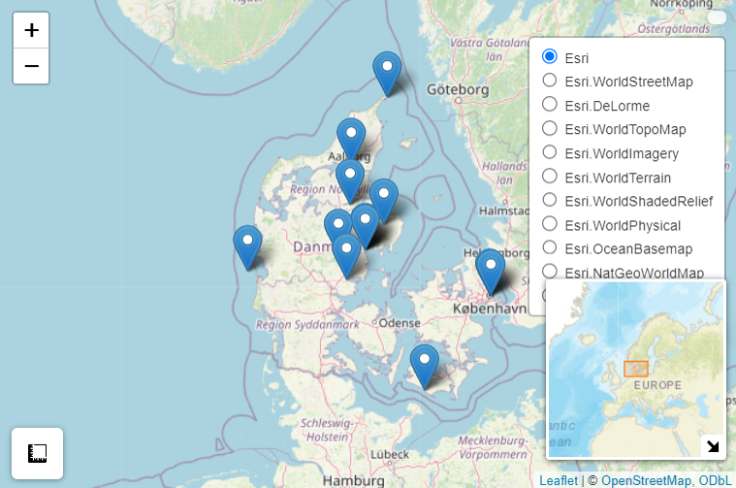

The image displays an interactive map of Denmark created using the R leaflet package, incorporating multiple Esri background layers and markers representing various locations. These locations, sourced from a Google Sheets dataset, correspond to leisure places with associated latitude, longitude, descriptions, and classifications. What makes this map special is its high level of interactivity and functionality. Users can switch between different Esri map styles, such as satellite imagery, topographic maps, and street maps, to enhance data visualization. The blue markers pinpoint specific locations, allowing users to explore different places across Denmark. A MiniMap in the bottom right corner provides a broader geographic context, while zoom and pan controls enable detailed navigation. Additionally, a measurement tool allows users to calculate distances and areas within the map, adding a spatial analysis component. Clicking on a marker would likely display a popup with information about the location, further enriching the user experience. This map effectively integrates various GIS elements, making it a powerful tool for geographic exploration and decision-making.